## 1.INTRODUCTION

### 1.1 Project Overview

The credit system governed by the banks is one of the most important factors which affect our country’s economy and ﬁnancial condition. Also, credit risk is one of the main functions of the banking community. The prediction of credit defaulters is one of the diﬃcult tasks for any bank. This problem occurs when the banks need to provide loans to the customers who are in need of the money. But by forecasting the loan defaulters, the banks deﬁnitely may reduce their loss by reducing their non-proﬁt assets.

### 1.2 Purpose

People who need loan and want to check whether they are eligible for loan or not.Thepurpose of a loan matters because lenders use this information to not only determine your interest rates, but also whether you qualify for a loan through that lender. The purpose of a loan to determine whether you need to borrow and have the ability to make payments.The goal of this system is to provide a quick, immediate and easy way to select good applicants. It can offer banks special benefits. The credit forecasting system can automatically calculate the weights for each feature that participates in credit processing, and the new test data will process the same features for the assigned weights. The model can set a deadline to see if the applicant can approve the loan. Credit analysis allows to jump to specific applications and check according to priority. This system is exclusively for bank / financial company management authorities, the entire forecasting process is carried out privately and no stakeholders can change the process. The results of a particular credit ID can be sent to various departments of the bank so that they cantake appropriate action on demand. This helps all other departments handle other paperwork

## 2.Literature survey

### 2.1 Existing Problem

### 

|  |  |  |  |
| --- | --- | --- | --- |
| Project Title | Algorithms used | Advantages | Disadvantages |
| Data Mining to Predict College Admissions Yield | Multiple linear Regression | Data-miningtechnology's predictive modelling was applied to enhance the prediction of theenrollmentbehaviors of the admitted applicants at a large state university | Loading of website takes time |
| The module of predictionof College Entrance Examination aspiration | Random Forest |  |  |

### 2.2 References

● S. Vimala, K.C. Sharmili, ―Prediction of Loan Risk using NB and Support Vector Machineǁ, International Conference on Advancements in Computing Technologies (ICACT 2018), vol. 4, no. 2, pp. 110-113, 2018.

● Pidikiti Supriya, Myneedi Pavani, Nagarapu Saisushma, Namburi Vimala Kumari, K. Vikas, ―Loan Prediction by using Machine Learning

● X. Francis Jency, V.P.Sumathi, Janani Shiva Sri, ―An Exploratory Data Analysis for Loan Prediction Based on Nature of the Clientsǁ, International Journal of Recent Technology and Engineering (IJRTE), Vol. 7, No. 48, pp. 176-179, 2018

● Anchal Goyal, Ranpreet Kaur, ―Loan Prediction Using Ensemble Techniqueǁ, International Journal of Advanced Research in Computer and Communication Engineering, Vol. 5, Issue 3, pp. 523 – 526, March 2016

### 2.3 Problem Statement Definition

Students are often worried about their chances of admission to University. The aim of this project is to help students in shortlisting universities with their profiles. The predicted output gives them a fair idea about their admission chances in a particular university. This analysis should also help students who are currently preparing or will be preparing to get a better idea.

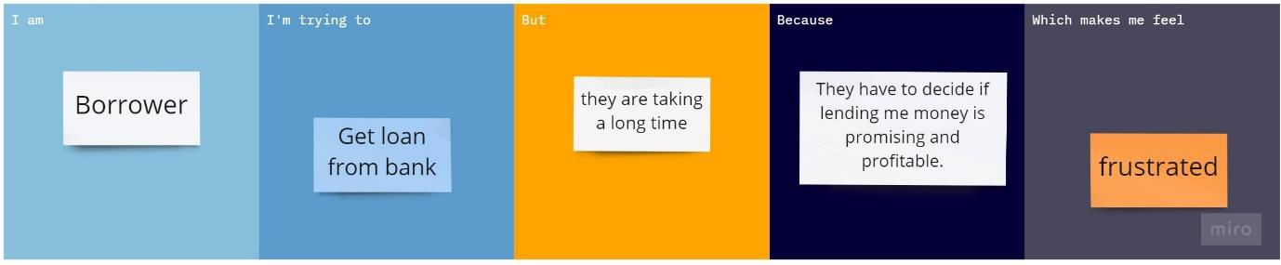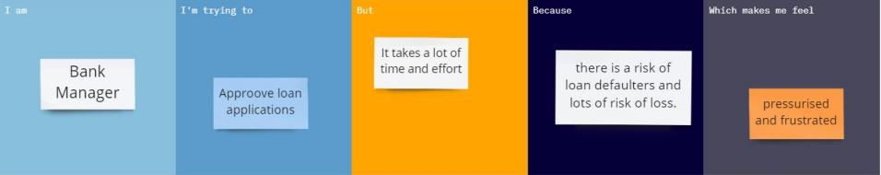

|  |  |  |  |  |  |
| --- | --- | --- | --- | --- | --- |
| **Problem**  **Statement (PS)** | **I am**  **(Customer)** | **I’m trying to** | **But** | **Because** | **Which makes me feel** |
| PS-1 | Bank Manager | Approve loan applications | It takes a lot of time and effort | There is a risk of loan defaulters and lots of  risk of loss | Pressurised and frustrated |
| PS-2 | Borrower | Get loan from bank | They are taking a long time | They have to decide if lending me money is promising and  profitable. | frustrated |

## 

## 3.IDEATION AND PROPOSED SOLUTION

### 3.1 Empathy Map Canvas

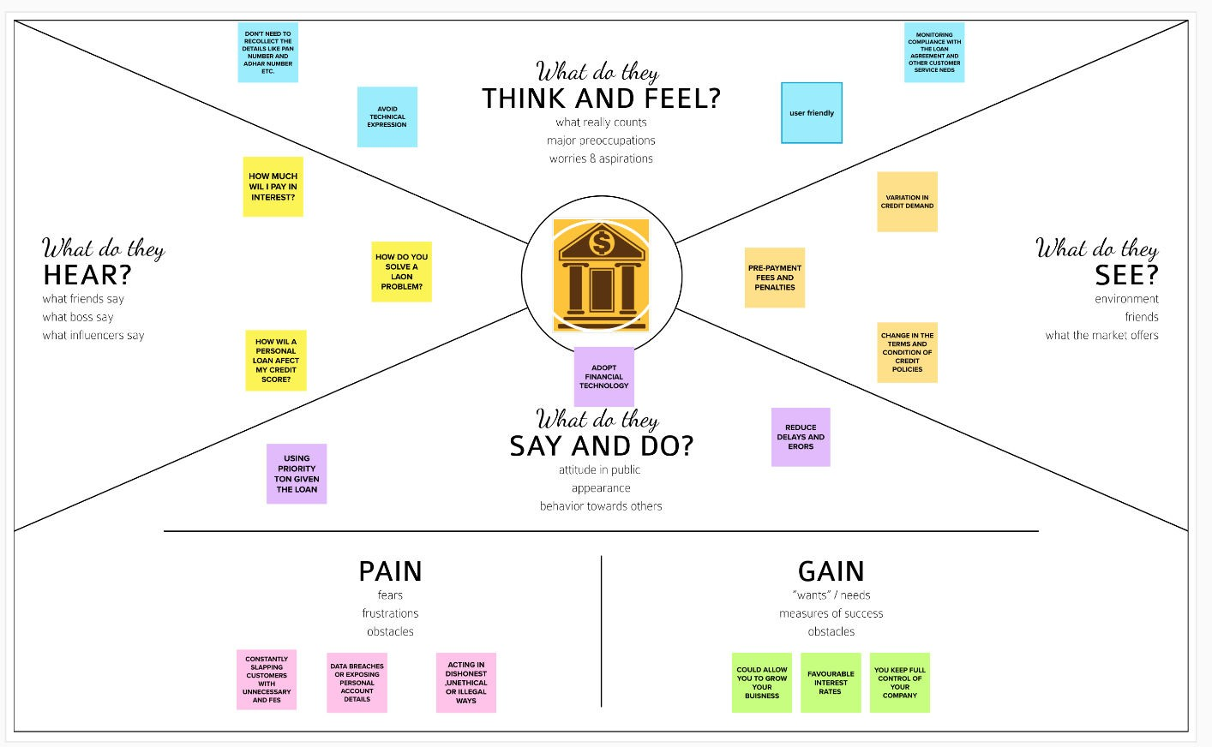

### 

### 

### 3.2 Ideation and Brainstorming

**Step-1: Team Gathering, Collaboration and Select the Problem Statement**

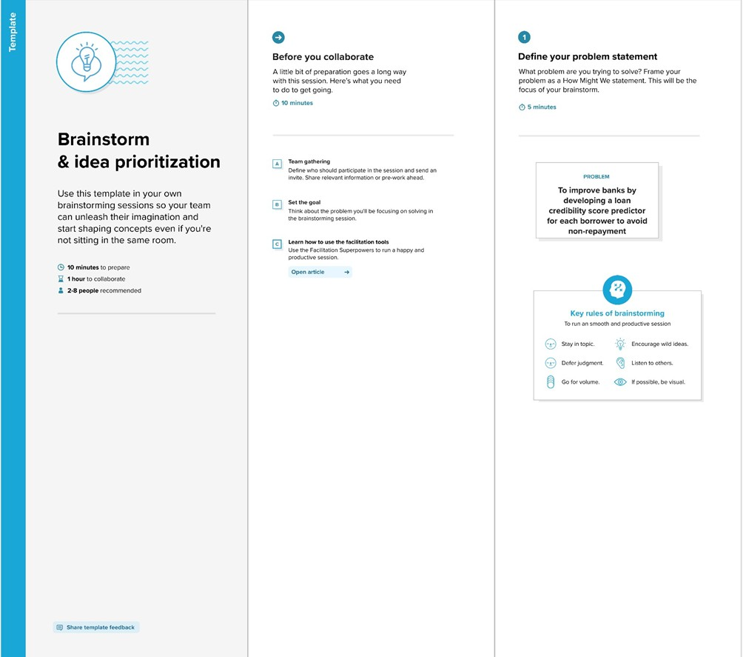

**Step-2: Brainstorm, Idea Listing and Grouping**

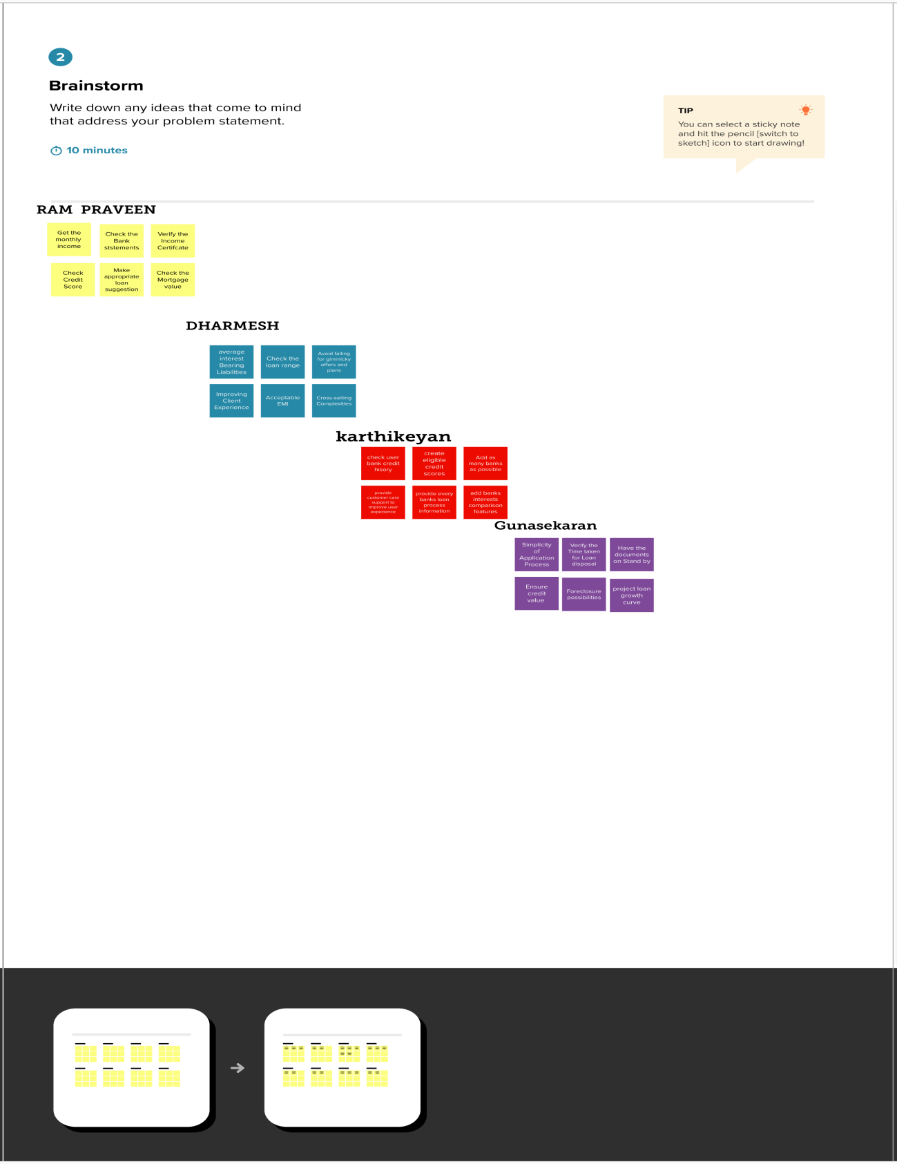

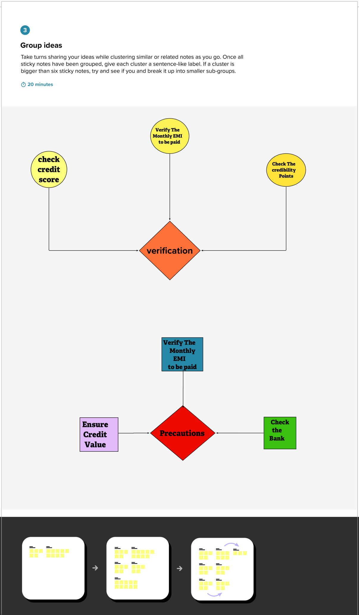

**Step-3: Idea Prioritization**

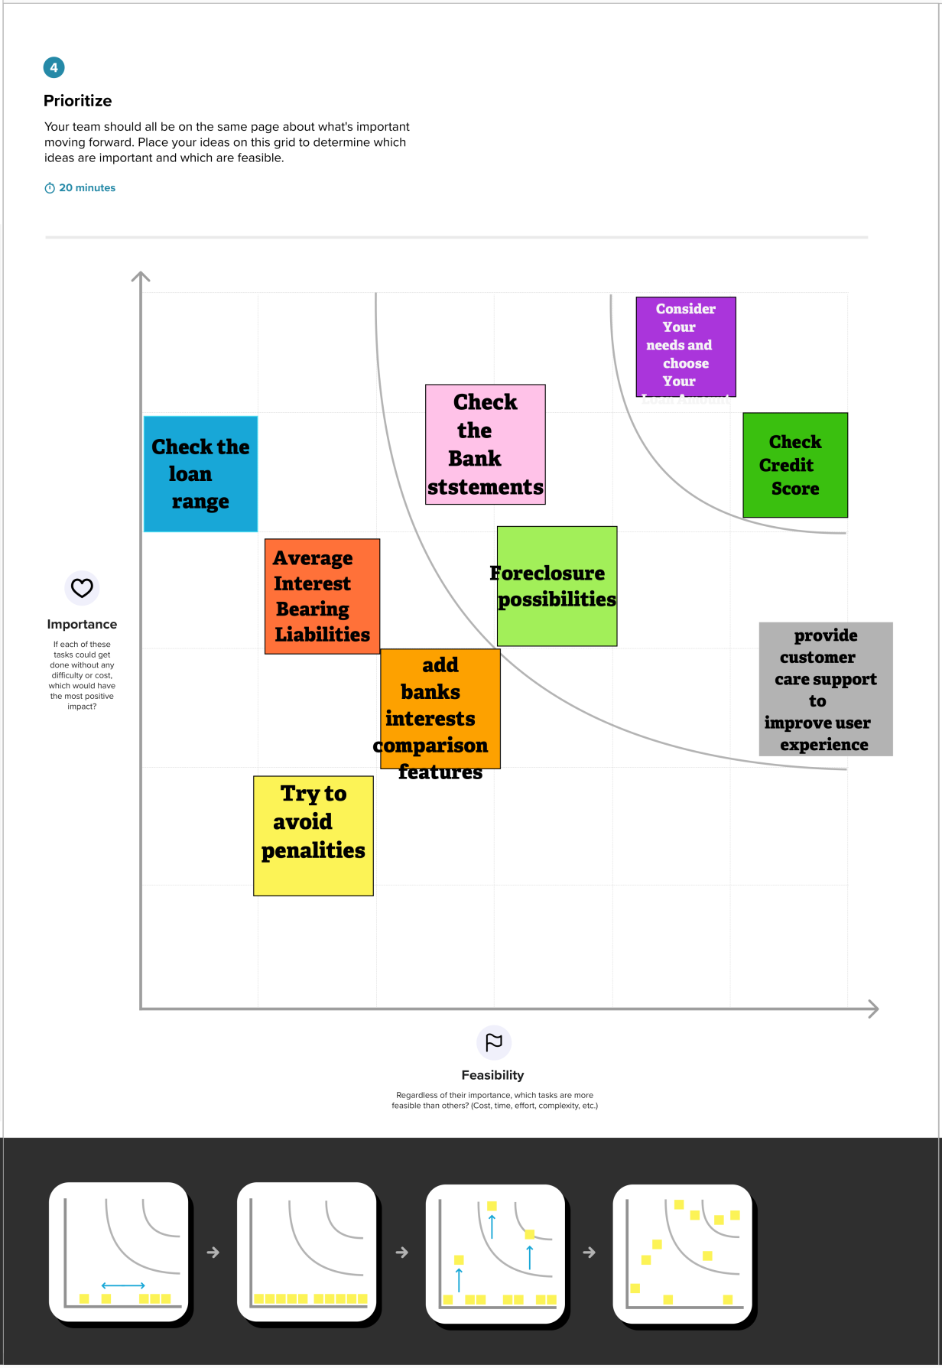

### 

### 3.3 Proposed Solution

|  |  |  |
| --- | --- | --- |
| **S.No.** | **Parameter** | **Description** |
| 1. | Problem Statement (Problem to be solved) | The credit system governed by the banks is one of the most important factors which affect our country’s economy and financial condition. Also, credit risk is one of the main functions of the banking community. The prediction of credit defaulters is one of the difficult tasks for any bank. This problem occurs when the banks need to provide loans to the customers who are in need of the money. But by forecasting the loan defaulters, the banks definitely may reduce their loss by reducing their non-profit assets. |
| 2. | Idea / Solution Description | This solution uses Machine Learning techniques which can be used to perform such classifications of the credit defaulters as they are very crucial and useful in the prediction of these types of data. Classification algorithms such as Decision tree, Random forest, KNN, Xgboost and SVM will be used. The data is trained and tested with these algorithms and finally, the best model is selected and saved in pkl format. Then, flask integration and IBM deployment will be done. |
| 3. | Novelty / Uniqueness | The solution tries to use the best model from the mentioned five models and classify the applicants with least error. |
| 4. | Social Impact / Customer Satisfaction | This application will help the bank employees to classify the credit defaulters accurately with minimum error. So, the non - profit losses of the banks have been reduced. Thus, they may recover the approved loans with minimum losses. |
| 5. | Business Model | The model can be implemented as a pay per month use model. The bank employees can pay the monthly or yearly subscription. Another option is to sell the model to the bank that pays the amount which is most profitable to developers. |
| 6. | Scalability of the Solution | The front end of the application is modular. Python Web Framework is used to do so. The bank end uses the flask integration. Therefo different features can be implemented and new pages can be added easily. |

### 3.4 Problem Solution Fit

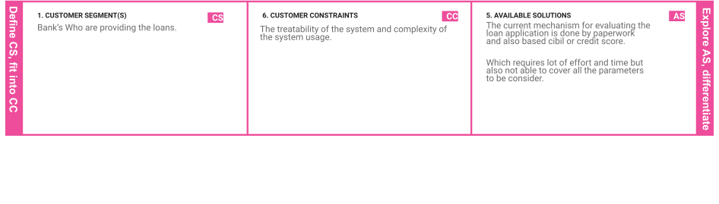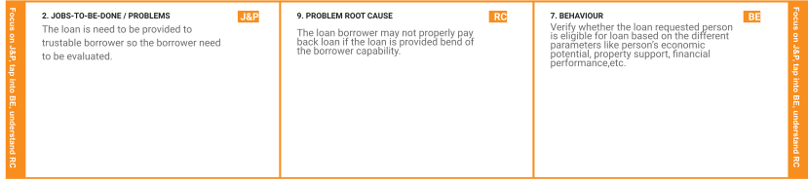

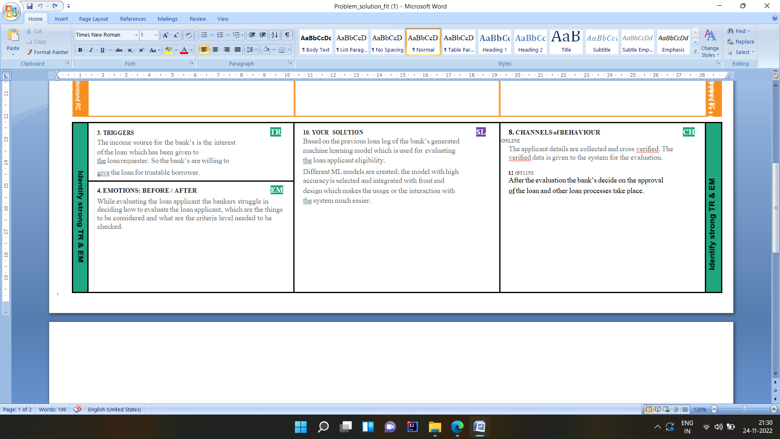

## 

## 

## 4.REQUIREMENT ANALYSIS

### 4.1 Functional Requirements

|  |  |  |
| --- | --- | --- |
| **FR**  **No.** | **Functional Requirement (Epic)** | **Sub Requirement (Story / Sub-Task)** |
| FR-1 | Home Page | * Smart Lender Applicant Credibility description * Information about Credibility details required for loan approval * if new user , REGISTER * if already exist , SIGN IN |
| FR-2 | User Registration | Enter Mail Id and other personal details required for Registering |
| FR-3 | User login | User Mail Id and Password for Login |
| FR-4 | Loan Approval form | Credibility details should be entered for prediction |
| FR-5 | Result | if Approved - It display the information about what is done to be next.  if Not Approved - It display the information about what rejection criteria you are not eligible for the loan. |

### 

### 4.2 Non-Functional Requirements

|  |  |  |
| --- | --- | --- |
| **FR No.** | **Non-Functional Requirement** | **Description** |
| NFR-1 | **Usability** | It describes the context Who,What,When,Where and Why. The specific activities the requirements describe should reflect the both range of goal that the system must support and business goals for creating new system. |
| NFR-2 | **Security** | Security functionality that ensures one of many different security properties of software is being satisfied.Security requirements are derived from  industry standards,applicable laws,and a history pf past vulnerabilities. |
| NFR-3 | **Reliability** | It is the measure of the stability or consistency of the test score |
| NFR-4 | **Performance** | It defines how well the software system  accomplishes certain functions under specific condition. |
| NFR-5 | **Availability** | It defines how long the IT system can be unavailable without impacting operations. |
| NFR-6 | **Scalability** | It is the measure of a system ability to increase or decrease in performance and cost in response |

## 

## 5. PROJECT DESIGN

### 5.1 Data Flow Diagram

### 

### 5.2 Solution and Technical Architecture

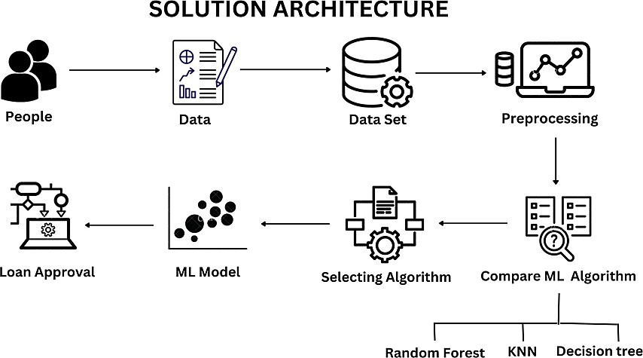

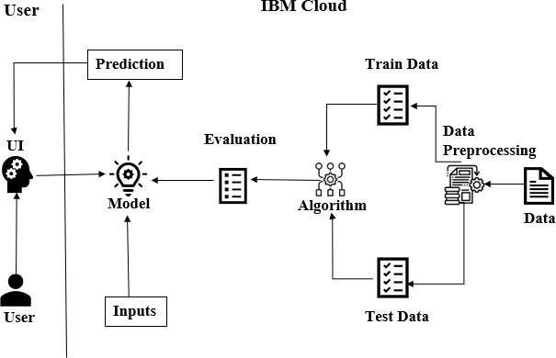

### 5.3 User Stories

|  |  |  |  |  |  |  |
| --- | --- | --- | --- | --- | --- | --- |
| **User Type** | **Functional Requirement**  **(Epic)** | **User Story Number** | **User Story / Task** | **Acceptance criteria** | **Priority** | **Release** |
| Customer  (Mobile user) | Home Page | USN - 1 | Loan approval prediction description | I can view /access my  homepage. | Low | Sprint - 3 |
|  |  | USN - 2 | Information about the credibility details required for the prediction |  | Low | Sprint - 3 |
|  | User Register | USN - 3 | Enter Email ID and other personal details  required for Register. | I can successfully register  by receiving mail. | Medium | Sprint - 2 |
|  | User Login | USN - 4 | Uses Email ID and Password for login | I have successfully logged  in. | Medium | Sprint - 2 |
|  | Loan approval Form | USN - 5 | Credibility details required for loan should be entered for prediction. | I can access the customer details form | High | Sprint - 1 |
|  | Result | USN - 6 | Results will be displayed. | I got my result successfully. | High | Sprint - 1 |

## 

## 6.PROJECT PLANNING AND SCHEDULE

|  |  |  |  |  |  |  |
| --- | --- | --- | --- | --- | --- | --- |
| **Sprint** | **Functional Requirement (Epic)** | **User Story Number** | **User Story / Task** | **Story Points** | **Priority** | **Team Members** |
| Sprint-1 | Dataset | USN-4 | Downloading the dataset | 1 | High | Ram Praveen Dharmesh Gunasekaran Karthikeyan |
| Sprint-1 |  | USN-5 | Visualizing the dataset | 2 | Low | Ram Praveen Dharmesh Gunasekaran Karthikeyan |
| Sprint-1 |  | USN-6 | Pre-process the dataset | 3 | Medium | Ram Praveen Dharmesh Gunasekaran Karthikeyan |
| Sprint-1 | Machine Learning Model | USN-7 | KNN model building | 5 | High | Ram Praveen Dharmesh Gunasekaran Karthikeyan |
| Sprint-2 |  | USN-8 | Decision Tree model building | 5 | High | Ram Praveen Dharmesh Gunasekaran Karthikeyan |
| Sprint-2 |  | USN-9 | Naive Bayes model building | 5 | High | Ram Praveen Dharmesh Gunasekaran Karthikeyan |
| Sprint-2 |  | USN-10 | Fine Tuning the model | 3 | Low | Ram Praveen Dharmesh Gunasekaran Karthikeyan |
| Sprint-2 |  | USN-11 | Evaluation and saving of the models | 5 | High | Ram Praveen Dharmesh Gunasekaran Karthikeyan |
| Sprint-3 | Customer user interface | USN-12 | Model Integration with flask | 5 | High | Ram Praveen  Dharmesh Karthikeyan  Gunasekaran |
| Sprint-3 |  | USN-1 | As a user, I should be able to access the dashboard. | 3 | Medium | Ram Praveen  Dharmesh Karthikeyan  Gunasekaran |
| Sprint-3 |  | USN-2 | Select the type of loan | 3 | Low | Ram Praveen Dharmesh Gunasekaran Karthikeyan |
| Sprint-3 |  | USN-3 | Fill the application and check the eligibility of loan approval | 5 | High | Ram Praveen Dharmesh Gunasekaran Karthikeyan |

### 6.1 Sprint Planning and Estimation

|  |  |  |  |  |  |  |
| --- | --- | --- | --- | --- | --- | --- |
| **Sprint** | **Functional Requirement (Epic)** | **User Story Number** | **User Story / Task** | **Story Points** | **Priority** | **Team Members** |
| Sprint-4 | Deployed the website | USN-13 | Register on IBM Cloud | 3 | Low | Ram Praveen Dharmesh Gunasekaran Karthikeyan |
| Sprint-4 |  | USN-14 | Train the ML model on IBM Cloud | 5 | Medium | Ram Praveen Dharmesh Gunasekaran Karthikeyan |
| Sprint-4 |  | USN-15 | Deploy the website on IBM Cloud | 8 | High | Ram Praveen Dharmesh Gunasekaran Karthikeyan |

### 

### 6.2 Sprint Delivery Schedule

|  |  |  |  |  |  |  |
| --- | --- | --- | --- | --- | --- | --- |
| **Sprint** | **Total Story Points** | **Duration** | **Sprint Start Date** | **Sprint End Date (Planned)** | **Story Points Completed (as on Planned End Date)** | **Sprint Release Date (Actual)** |
| Sprint-1 | 11 | 6 Days | 24 Oct 2022 | 29 Oct 2022 | 11 | 29 Oct 2022 |
| Sprint-2 | 18 | 6 Days | 31 Oct 2022 | 05 Nov 2022 | 18 | 05 Nov 2022 |
| Sprint-3 | 16 | 6 Days | 07 Nov 2022 | 12 Nov 2022 | 16 | 12 Nov 2022 |
| Sprint-4 | 16 | 6 Days | 14 Nov 2022 | 19 Nov 2022 | 16 | 19 Nov 2022 |

### 

### 6.3 Reports from JIRA

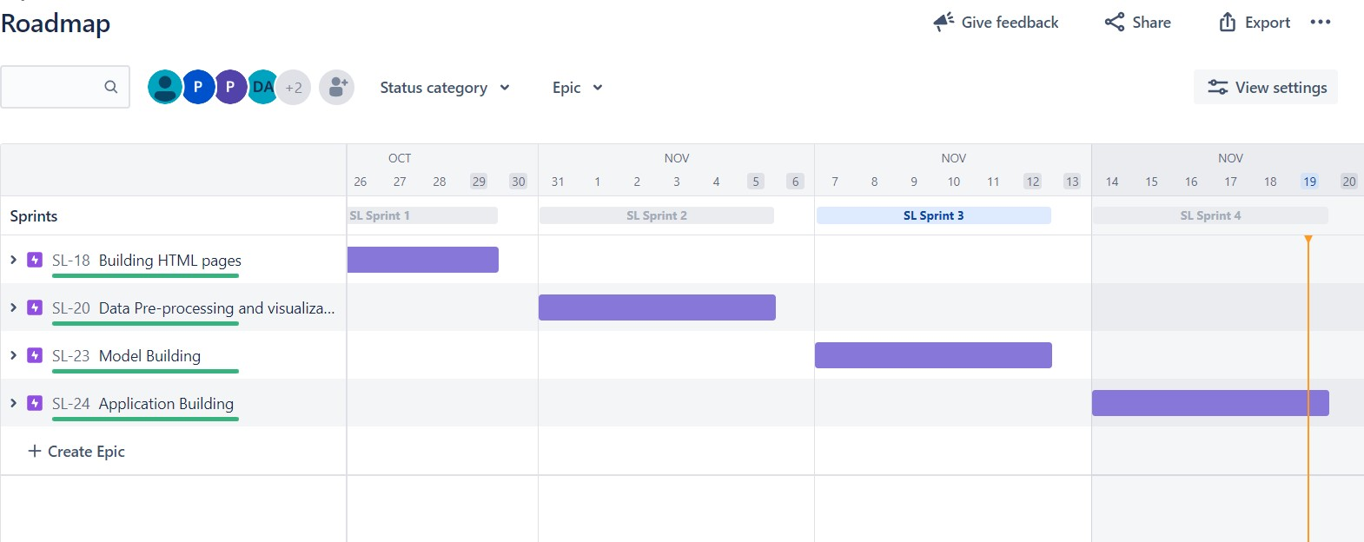

## 

## 7.CODING AND SOLUTIONING

### 7.1 Feature 1

The customer ﬁrst applies for a loan and after that, the company validates the customer eligibility for the loan.The customer wants to automate the loaneligibility process (real-time) based on their details provided while ﬁlling out online application forms. These details are Gender, Marital Status, Education, number of Dependents, Income, Loan Amount, Credit History, and others.To automate this process, we have provided a dataset to identify the customer segments that are eligible.

This model will characterize the behavior and eligibility of customers on the basis of their records. These records are taken from the customers, and a data set is created. With the help of these data sets and training machine learning model, the customer’s loan credibility is checked.

.

**home.html**

**<!doctype html>**

**<html>**

**<head>**

**<meta charset="utf-8">**

**<link rel="stylesheet" href="https://cdn.jsdelivr.net/npm/bootstrap@4.0.0/dist/css/bootstrap.min.css"**

**integrity="sha384-Gn5384xqQ1aoWXA+058RXPxPg6fy4IWvTNh0E263XmFcJlSAwiGgFAW/dAiS6JXm" crossorigin="anonymous">**

**<title>Loan Prediction</title>**

**<link rel="stylesheet" href="{{url_for('static', filename='/home.css')}}">**

**</head>**

**<body>**

**<section>**

**<div class='landpage'>**

**<center>**

**<h1><b>Smart Lender</b>**

**<br>**

**Applicant Credibility Prediction For Loan Approval**

**</h1>**

**<p class="text-center">Predit your loan eligibility here</p>**

**<a href="prediction.html" class="btn">**

**<button type="button" class="btn btn-dark">Predict</button>**

**</a>**

**</center>**

**</div>**

**<center>**

**<img src="https://img.freepik.com/free-vector/money-lending-abstract-concept_335657-3053.jpg?w=2000">**

**</center>**

**</section>**

**</body>**

**</html>**

### 7.2 Feature 2

**prediction.html**

**<!doctype html>**

**<html lang="en">**

**<head>**

**<!-- Required meta tags -->**

**<meta charset="utf-8">**

**<meta name="viewport" content="width=device-width, initial-scale=1">**

**<!-- Bootstrap CSS -->**

**<link rel="stylesheet" href="{{url_for('static', filename='/prediction.css')}}">**

**<link href="https://cdn.jsdelivr.net/npm/bootstrap@5.0.0-beta3/dist/css/bootstrap.min.css" rel="stylesheet"**

**integrity="sha384-eOJMYsd53ii+scO/bJGFsiCZc+5NDVN2yr8+0RDqr0Ql0h+rP48ckxlpbzKgwra6" crossorigin="anonymous">**

**<link href="https://unpkg.com/tailwindcss@^2/dist/tailwind.min.css" rel="stylesheet">**

**<link rel="stylesheet" href="https://cdn.jsdelivr.net/npm/bootstrap@4.0.0/dist/css/bootstrap.min.css"**

**integrity="sha384-Gn5384xqQ1aoWXA+058RXPxPg6fy4IWvTNh0E263XmFcJlSAwiGgFAW/dAiS6JXm" crossorigin="anonymous">**

**<title>prediction</title>**

**</head>**

**<body>**

**<script>**

**function valid() {**

**var Ai = document.getElementById("ApplicantIncome").value;**

**var Co = document.getElementById("CoapplicantIncome").value;**

**var LA = document.getElementById("LoanAmount").value;**

**var LT = document.getElementById("Loan_Amount_Term").value;**

**if (Ai > 100000000000000000000000000000000000000) {**

**alert("Applicant income is too large enter a valid number")**

**return false;**

**}**

**if (Co > 100000000000000000000000000000000000000) {**

**alert("Coapplicant income is too large enter a valid number")**

**return false;**

**}**

**if (LA > 100000000000000000000000000000000000000) {**

**alert("Loan Amount is too large enter a valid number")**

**return false;**

**}**

**if (LT > 100000000000000000000000000000000000000) {**

**alert("loan amount term is too large enter a valid number")**

**return false;**

**}**

**var name = document.getElementById("Name").value;**

**var letters = /^[a-zA-Z]*$/;**

**if (!name.match(letters)) {**

**alert("Name must contain only alphabets")**

**return false;**

**}**

**var num = /^[0-9]+$/;**

**if (!Ai.match(num)) {**

**alert("Enter only valid numbers alphabets are not allowed ")**

**return false;**

**}**

**if (!Co.match(num)) {**

**alert("Enter only valid numbers alphabets are not allowed ")**

**return false;**

**}**

**if (!LA.match(num)) {**

**alert("Enter only valid numbers alphabets are not allowed ")**

**return false;**

**}**

**if (!LT.match(num)) {**

**alert("Enter only valid numbers alphabets are not allowed ")**

**return false;**

**}**

**var mo = document.getElementById("mon").value;**

**var mn = /^[0-9]{10}$/;**

**if (!mo.match(mn)) {**

**alert("Please enter only 10 digit mobile number")**

**return false;**

**}**

**}**

**</script>**

**<section class="text-green-800 body-font">**

**<div class="container px-1 py-12 mx-auto">**

**<div class="flex flex-col text-center mb-10">**

**<h1 class="Heading">Loan Eligibility Prediction</h1><br>**

**<p class="fill">Fill the form for prediction</p>**

**</div>**

**<div>**

**</div>**

**<form action='/prediction.html' method="post" onsubmit="return valid()" class="px-24 mx-12">**

**<div class="mb-3">**

**<label for="exampleFormControlInput1" class="form-label">Name</label>**

**<input type="text" class="form-control" id="Name" name="Name" placeholder="Enter your Name" required>**

**</div>**

**<div class="mb-3">**

**<label for="exampleFormControlInput1" class="form-label">Email ID</label>**

**<input type="email" class="form-control" id="email" name="email" placeholder="Enter your Email ID" required>**

**</div>**

**<div class="mb-3">**

**<label for="exampleFormControlInput1" class="form-label">Mobile Number</label>**

**<input type="text" class="form-control" id="mon" name="mon" placeholder="Enter your Mobile Number" required>**

**</div>**

**<div class="mb-3">**

**<label for="exampleFormControlInput1" class="form-label">Gender</label>**

**<select class="form-select" id="gender" name="gender" aria-label="Default select example" required>**

**<option selected>-- Select Gender --</option>**

**<option value="Male">Male</option>**

**<option value="Female">Female</option>**

**</select>**

**</div>**

**<div class="mb-3">**

**<label for="exampleFormControlInput1" class="form-label">Married</label>**

**<select class="form-select" id="married" name="married" aria-label="Default select example" required>**

**<option selected>-- Select Status --</option>**

**<option value="Yes">Yes</option>**

**<option value="No">No</option>**

**</select>**

**</div>**

**<div class="mb-3">**

**<label for="exampleFormControlInput1" class="form-label">Dependents</label>**

**<select class="form-select" id="dependents" name="dependents" aria-label="Default select example" required>**

**<option selected>-- Select Dependents --</option>**

**<option value="0">0</option>**

**<option value="1">1</option>**

**<option value="2">2</option>**

**<option value="3+">3+</option>**

**</select>**

**</div>**

**<div class="mb-3">**

**<label for="exampleFormControlInput1" class="form-label">Education</label>**

**<select class="form-select" id="education" name="education" aria-label="Default select example" required>**

**<option selected>-- Select Education --</option>**

**<option value="Graduate">Graduate</option>**

**<option value="Not Graduate">Not Graduate</option>**

**</select>**

**</div>**

**<div class="mb-3">**

**<label for="exampleFormControlInput1" class="form-label">Self Employed</label>**

**<select class="form-select" id="employed" name="employed" aria-label="Default select example" required>**

**<option selected>-- select Self Employed --</option>**

**<option value="Yes">Yes</option>**

**<option value="No">No</option>**

**</select>**

**</div>**

**<div class="mb-3">**

**<label for="exampleFormControlInput1" class="form-label">Credit History</label>**

**<select class="form-select" id="credit" name="credit" aria-label="Default select example" required>**

**<option selected>-- select Credit History --</option>**

**<option value="Yes">Yes</option>**

**<option value="No">No</option>**

**</select>**

**</div>**

**<div class="mb-3">**

**<label for="exampleFormControlInput1" class="form-label">Property Location</label>**

**<select class="form-select" id="proparea" name="proparea" aria-label="Default select example" required>**

**<option selected>-- select Property Location --</option>**

**<option value="Semiurban">Semiurban</option>**

**<option value="Urban">Urban</option>**

**<option value="Rural">Rural</option>**

**</select>**

**</div>**

**<div class="mb-3">**

**<label for="exampleFormControlInput1" class="form-label">Enter Applicant Income</label>**

**<input type="text" class="form-control" id="ApplicantIncome" name="ApplicantIncome"**

**placeholder="Applicant Income" required>**

**</div>**

**<div class="mb-3">**

**<label for="exampleFormControlInput1" class="form-label">Enter Co-applicant Income</label>**

**<input type="text" class="form-control" id="CoapplicantIncome" name="CoapplicantIncome"**

**placeholder="Co-applicant Income" required>**

**</div>**

**<div class="mb-3">**

**<label for="exampleFormControlInput1" class="form-label">Purpose of loan</label>**

**<select class="form-select" id="pur" name="pur" aria-label="Default select example" required>**

**<option selected>-- select the purpose of loan --</option>**

**<option value="person">Personal Loan</option>**

**<option value="Bussiness">Business Loan</option>**

**<option value="Education">Education Loan</option>**

**<option value="Home">Home Loan</option>**

**<option value="Other">Other</option>**

**</select>**

**</div>**

**<div class="mb-3">**

**<label for="exampleFormControlInput1" class="form-label">Enter Loan Amount</label>**

**<input type="text" class="form-control" id="LoanAmount" name="LoanAmount" placeholder="Loan Amount" required>**

**</div>**

**<div class="mb-3">**

**<label for="exampleFormControlInput1" class="form-label">Enter Loan Amount Term</label>**

**<input type="text" class="form-control" id="Loan_Amount_Term" name="Loan_Amount_Term"**

**placeholder="Loan Amount Term" required>**

**</div>**

**<div class="mb-3">**

**<label for="exampleFormControlInput1" class="form-label">Enter Aadhar Number</label>**

**<input type="text" class="form-control" id="Adhar" name="Adhar" placeholder="Aadhar Number" required>**

**</div>**

**<div class="mb-3">**

**<label for="exampleFormControlInput1" class="form-label">Enter PAN Card ID</label>**

**<input type="text" class="form-control" id="PAN " name="PAN " placeholder="PAN Card ID" required>**

**</div>**

**<br><br>**

**<div class="mb-3">**

**<button type="submit" value="PREDICT" class="btn btn-dark">Predict</button>**

**</div>**

**</form>**

**</div>**

**</section>**

**<script src="https://cdn.jsdelivr.net/npm/bootstrap@5.0.0-beta3/dist/js/bootstrap.bundle.min.js"**

**integrity="sha384-JEW9xMcG8R+pH31jmWH6WWP0WintQrMb4s7ZOdauHnUtxwoG2vI5DkLtS3qm9Ekf"**

**crossorigin="anonymous"></script>**

**</body>**

**<style>**

**body{**

**font-family: Arial, Helvetica, sans-serif;**

**font-variant: small-caps;**

**}**

**</style>**

**</html>**

**approve.html**

**<!DOCTYPE html>**

**<html lang="en" dir="ltr">**

**<head>**

**<meta charset="utf-8">**

**<title>Loan approva status</title>**

**<link rel="stylesheet" href="static/approve.css">**

**<link rel="stylesheet" href="https://cdnjs.cloudflare.com/ajax/libs/font-awesome/5.15.3/css/all.min.css"/>**

**<link rel="stylesheet" href="https://cdn.jsdelivr.net/npm/bootstrap@4.0.0/dist/css/bootstrap.min.css" integrity="sha384-Gn5384xqQ1aoWXA+058RXPxPg6fy4IWvTNh0E263XmFcJlSAwiGgFAW/dAiS6JXm" crossorigin="anonymous"> </head>**

**<body>**

**<h2>{{prediction_text}}</h2>**

**<img src="static/money.jpeg" width="30%" height="75%">**

**</body>**

**</html>**

**Reject.html**

**<!DOCTYPE html>**

**<html lang="en" dir="ltr">**

**<head>**

**<meta charset="utf-8">**

**<title>Loan approval status</title>**

**<link rel="stylesheet" href="static/reject.css">**

**<link rel="stylesheet" href="https://cdnjs.cloudflare.com/ajax/libs/font-awesome/5.15.3/css/all.min.css"/>**

**<link rel="stylesheet" href="https://cdn.jsdelivr.net/npm/bootstrap@4.0.0/dist/css/bootstrap.min.css" integrity="sha384-Gn5384xqQ1aoWXA+058RXPxPg6fy4IWvTNh0E263XmFcJlSAwiGgFAW/dAiS6JXm" crossorigin="anonymous"> </head>**

**<body>**

**<h2>{{prediction_text}}</h2>**

**<img src="static/rejected.jpeg" width="30%" height="75%">**

**</body>**

**</html>**

### 7.3 Database Schema

### Screenshot (342).png

## 

## 8. TESTING

### 8.1 Test Cases

|  |  |  |  |  |  |  |  |  |  |  |  |  |
| --- | --- | --- | --- | --- | --- | --- | --- | --- | --- | --- | --- | --- |
| **Test ccase ID** | **Feature Type** | **Component** | **Test Scenario** | **Pre-**  **Requisite** | **Steps To Execute** | **Expected Result** | **Actual Result** | **Status** | **Comments** | **TC for**  **Automation(Y/N)** | **BuG ID** | **Executed By** |
| tc01 | Functional | e Page | Verify  user is able to click on Predict button |  | 1.Enter  URL and ﬁll the form 2.Click on Predict button | Loan form  should display | Working as expected | Pass |  |  |  |  |
| tc02 | Function al | Home Page | The web  page is getting refreshed |  | 1.Automatic page reload | Loan form  must appear automatically after page reload | Working as expected | Fail | No steps needed | Y | BUG- 1234 |  |
| tc03 | Function al | Home page | Field address  validation |  | 1. Double-  click on the E-mail address ﬁeld | User should  navigate to E-mail address ﬁeld | Working as expected | Pass |  |  |  |  |
| tc04 | Function al | Output page | Loan  Credibility predicted output |  | 1. Click on  predict button 2. View the predicted results | User should  access the Loan credibility predicted result | Working as expected | Pass |  |  |  |  |

### User Acceptance Testing

**1.Purpose of Document**

The purpose of this document is to brieﬂy explain the test coverage and open issues of the [ProductName] project at the time of the release to User Acceptance Testing

**2.Defect Analysis**

This report shows the number of resolved or closed bugs at each severity level, and how they were resolved

|  |  |  |  |  |  |
| --- | --- | --- | --- | --- | --- |
| **Resolution** | **Severity 1** | **Severity 2** | **Severity 3** | **Severity 4** | **Subtotal** |
| By Design | 9 | 3 | 1 | 2 | 15 |
| Duplicate | 0 | 0 | 4 | 0 | 4 |
| External | 1 | 2 | 0 | 0 | 3 |
| Fixed | 10 | 5 | 4 | 21 | 40 |
| Not Reproduced | 0 | 0 | 0 | 0 | 0 |
| Skipped | 0 | 0 | 0 | 0 | 0 |
| Won't Fix | 0 | 0 | 0 | 0 | 0 |
| Totals | 20 | 9 | 9 | 23 | 6  4 |

### 

## 

|  |  |  |  |  |
| --- | --- | --- | --- | --- |
| **Section** | **Total Cases** | **Not Tested** | **Fail** | **Pass** |
| Print Engine | 5 | 0 | 0 | 5 |
| Client Application | 46 | 0 | 0 | 46 |
| Security | 4 | 0 | 0 | 4 |
| Outsource Shipping | 3 | 0 | 0 | 3 |
| Exception Reporting | 7 | 0 | 0 | 7 |
| Final Report Output | 4 | 0 | 0 | 4 |
| Version Control | 2 | 0 | 0 | 2 |

## 9.RESULTS

### 9.1 Performance Metrics

Model Performance Testing:

Project team shall ﬁll the following information in the model performance testing template.

|  |  |  |
| --- | --- | --- |
| **S.No.** | **Parameter** | **Screenshot / Values** |
| 1 | Data Responsiveness | The ML model takes about 0.3 seconds to process the  dataset. The credibility result is predicted in approximately 0.9 seconds. |
| 2 | Utilisation of Data  Filters | Suﬃcient data ﬁlters have been used for ideal model  building |
| 3 | Effective User Story | No of Scene Added - 15 |
| 4 | Descriptive Reports | No of Visualisations / Graphs - 13 |

## 

## 

## 10.ADVANTAGES AND DISADVANTAGES

### Advantages:

**Keep control of the company**

A bank loans money to a business based on the value of the business and its perceived ability to service the loan by making payments on time and in full.Unlike with equity finance where the business issues shares,banks do not take any ownership position in businesses.

**Bank Loan is Temporary**

Once a business borrower has paid off a loan,there is no more obligation to or involvement with The bank lender unless the borrower wishes to take out a subsequent loan.compare this with equity finance,where the company may be paying out dividends to shareholders for as along as the business exist.

### 

### Disadvantages

## Tough to quality

One of the greatest disadvantages to bank loans is that they are very difficult to obtain from unless a small business has a substantial track record or valuable collateral such as real estate.Bank are careful to lend only to businesses that can clearly repay their loans,and they also make sure thatthey are able to cover losses in the event of default

**High Interest Rates**

Interest rates for small-business loans from banks can be quite high, and the amount of bank funding for which a business qualiﬁes is often not suﬃcient to completely meet its needs. The high interest rate for the funding a business does receive often stunts its expansion, because the business needs to not only service the loan but also deal with additional funding to cover funds not provided by the bank. Loans guaranteed by the U.S. Small Business Administration offer better terms than other loans, but the requirements to qualify for these subsidized bank loans are very strict.

## 11.CONCLUSION

The analysis starts from data cleaning and processing missing value, exploratory analysis and ﬁnally model building and evaluation of the model. The best accuracy on public test set is when we get higher accuracy score and other performance metrics which will be found out. This project can help to predict the approval of bank loan or not for a candidate

## 12.FUTURE SCOPE

In order to analyse the risk associated for the bank, credit evaluation largely involves gathering information about the customer and examining the project's technical, ﬁnancial, and economic viability and this process developed a lot.

### 

## 

## 13.APPENDIX

**App.py**

## from flask import render_template, Flask, request

## import numpy as np

## import pickle

## from sklearn.preprocessing import scale

## app = Flask(__name__, template_folder='templates')

## model = pickle.load(open("model.pkl", 'rb'))

## @app.route('/')

## def home():

## return render_template('home.html')

## @app.route('/login.html')

## @app.route('/home.html')

## def home1():

## return render_template('home.html')

## @app.route('/prediction.html')

## def formpg():

## return render_template('prediction.html')

## @app.route('/prediction.html', methods=['POST'])

## def predict():

## if request.method == 'POST':

## name = request.form['Name']

## gender = request.form['gender']

## married = request.form['married']

## dependents = request.form['dependents']

## education = request.form['education']

## employed = request.form['employed']

## credit = request.form['credit']

## proparea = request.form['proparea']

## ApplicantIncome = float(request.form['ApplicantIncome'])

## CoapplicantIncome = float(request.form['CoapplicantIncome'])

## LoanAmount = float(request.form['LoanAmount'])

## Loan_Amount_Term = float(request.form['Loan_Amount_Term'])

## if gender == 'Male':

## gender = 1

## else:

## gender = 0

## if married == 'Yes':

## married = 1

## else:

## married = 0

## if education == 'Graduate':

## education = 0

## else:

## education = 1

## if employed == 'Yes':

## employed = 1

## else:

## employed = 0

## if dependents == '3+':

## dependents = 3

## if credit == 'Yes':

## credit = 1

## else:

## credit = 0

## if proparea == 'Urban':

## proparea = 2

## elif proparea == 'Rural':

## proparea = 0

## else:

## proparea = 1

## features = [gender, married, dependents, education, employed, ApplicantIncome,

## CoapplicantIncome, LoanAmount, Loan_Amount_Term, credit, proparea]

## con_features = [np.array(features)]

## prediction = model.predict(con_features)

## print(prediction)

## if prediction == 1:

## return render_template('approve.html', prediction_text='Congratulations! '+name+' You are eligible for loan')

## else:

## return render_template('reject.html', prediction_text='Sorry '+name+' You are not eligible for loan')

## if __name__ == "__main__":

## app.run(debug=True)

## 

## 13.2 GITHUB AND PROJECT DEMO LINK

### GitHub link:

<https://github.com/IBM-EPBL/IBM-Project-23600-1659888355>

### Project Demo Link:

<https://drive.google.com/file/d/1b0YreYfyfWs7agi8EfuQsuKRyoewf1NW/view?usp=share_link>